|  |  |  |  |
| --- | --- | --- | --- |
| Document | version | Prepared by | Review by |
| Testlink installation | V_01 | Rakesh Paliwal | Sumit malhotra |
|  |  |  |  |

**Test link installation on linux**

**Download Package from Bitnami site**

**Extract package :**

chmod 755 bitnami-testlink-1.9.20-9-linux-x64-installer.run

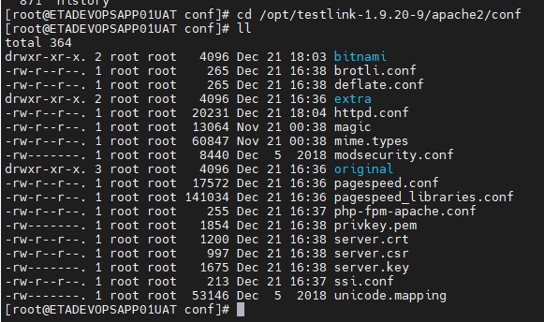

./bitnami-testlink-1.9.20-9-linux-x64-installer.run

umask 022

./bitnami-testlink-1.9.20-9-linux-x64-installer.run

env |grep proxy

vi /etc/environment

env |grep proxy

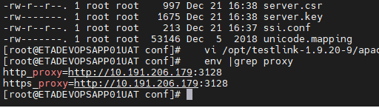

vi /opt/testlink-1.9.20-9/apache2/conf/httpd.conf

cd /opt/testlink-1.9.20-9/

vi apache2/conf/bitnami/bitnami.conf

/opt/testlink-1.9.20-9/ctlscript.sh restart apache

sudo /opt/testlink-1.9.20-9/ctlscript.sh restart apache

vi /opt/testlink-1.9.20-9/apache2/conf/httpd.conf

/opt/testlink-1.9.20-9/ctlscript.sh restart apache

/opt/testlink-1.9.20-9/ctlscript.sh restart apache

vi /opt/testlink-1.9.20-9/apache2/conf/httpd.conf

vi /opt/testlink-1.9.20-9/apache2/conf/bitnami/bitnami.conf

/opt/testlink-1.9.20-9/ctlscript.sh restart apache

vi /opt/testlink-1.9.20-9/apache2/conf/httpd.conf

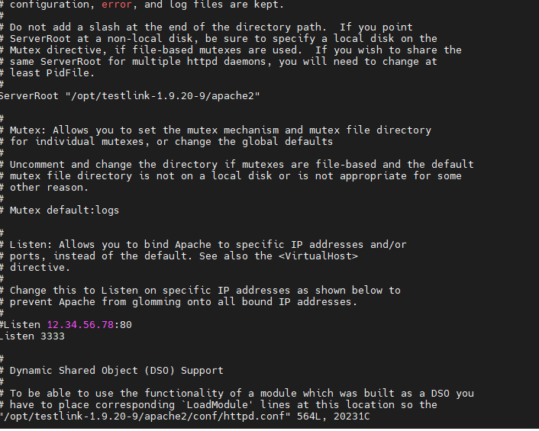

Add our customize port in above file

